LAB TUTORIAL :1

Q1. Write a program to implement a given DFA .

Code :

#include <iostream>
#include <bits/stdc++.h>
using namespace std;

int main() {
// your code goes here
string S;
cin>>S;
int n=S.length();
cout<<"string length:"<< n<<endl;
cout<<"SYMBOL --- next state -- Accept/reject"<<endl;
char instring[n];
strcpy(instring, S.c_str());

char currstate='A';
char finstate='E';
for(int i=0;i<n;i++){
switch(currstate){
case 'A':
switch(instring[i]){
case '0' :
currstate='B';
cout<<instring[i] <<" -- "<<currstate<<" rejected\n";
break;
case '1':
currstate='A';
cout<<instring[i] <<" -- "<<currstate<<" rejected\n";
break;
case '2':
currstate='B';
cout<<instring[i] <<" -- "<<currstate<<" rejected\n";
break;
default:
cout<<"Wrong input \n";
i=n;
break;

}
break;
case 'B':
switch(instring[i]){
case '0' :
currstate='E';
cout<<instring[i] <<" -- "<<currstate<<" acepted\n";
break;
case '1':
currstate='A';
cout<<instring[i] <<" -- "<<currstate<<" rejected\n";
break;
case '2':
currstate='C';
cout<<instring[i] <<" -- "<<currstate<<" rejected\n";
break;
default:
cout<<"Wrong input \n";
i=n;
break;
}
break;
case 'C':
switch(instring[i]){
case '0' :
currstate='A';
cout<<instring[i] <<" -- "<<currstate<<" rejected\n";
break;
case '1':
currstate='E';
cout<<instring[i] <<" -- "<<currstate<<" accepted\n";
break;
case '2':
currstate='D';
cout<<instring[i] <<" -- "<<currstate<<" rejected\n";
break;
default:
cout<<"Wrong input \n";
i=n;
break;

}
break;
case 'D':
switch(instring[i]){
case '0' :
currstate='C';
cout<<instring[i] <<" -- "<<currstate<<" rejected\n";
break;
case '1':
currstate='D';
cout<<instring[i] <<" -- "<<currstate<<" rejected\n";
break;
case '2':
currstate='E';
cout<<instring[i] <<" -- "<<currstate<<" accepted\n";
break;
default:
cout<<"Wrong input \n";
i=n;
break;

}
break;
case 'E':
switch(instring[i]){
case '0' :
currstate='E';
cout<<instring[i] <<" -- "<<currstate<<" accepted\n";
break;
case '1':
currstate='D';
cout<<instring[i] <<" -- "<<currstate<<" rejected\n";
break;
case '2':
currstate='A';
cout<<instring[i] <<" -- "<<currstate<<" rejected\n";
break;
default:
cout<<"Wrong input \n";
i=n;
break;

}
break;
default:
cout<<"wrong happened\n";
i=n;
break;

}
}
if(currstate=='E')
cout<<"Finally accepted...";
else
cout<<"Finally rejected ...";

return 0;
}

OUTPUT :
Here we are taking a DFA
States Input | 0 | 1 | 2
->A
B
C
D
*E

Input Strings 011201120 ouput = accepted
10122111010 ouput = accepted
101221110 ouput = rejected

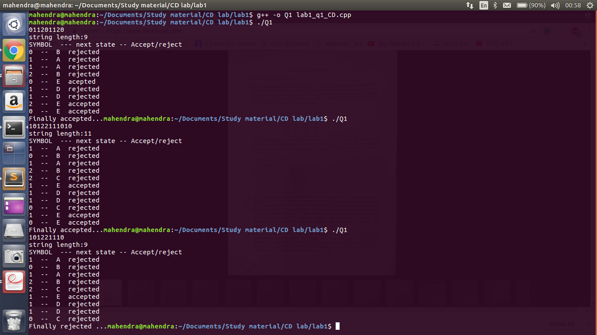

Q2. Write a program to implement a any given DFA .

Code :

#include <iostream>
#include <bits/stdc++.h>
#include <sstream>
#include <string>
using namespace std;

bool isFinal(char c, char* fin,int N){
bool found=false;
for(int i=0;i<N;i++){
if(fin[i]==c){
found= true;
break;
}
}
return found;
}

int main(){

int m=0,n=0;
// m states and n input symbols
cout<<"Enter #states and #symbol..\n";
cin>>m>>n;
char states[m];
cout<<"Enter states..\n";
for (int i=0;i<m;i++)
cin>>states[i];

char sym[n];
cout<<"Enter symbols..\n";
for (int i=0;i<n;i++)
cin>>sym[i];

cout<<"Enter table entry..\n";
char st[m][n];
for(int i=0;i<m;i++)
for(int j=0;j<n;j++)
cin>>st[i][j];

//char cst=states[0];
cout<<"Enter Number of final states..\n";
int f;
cin>>f;
char fst[f];
cout<<"Enter final states..\n";
for(int i=0;i<f;i++)
cin>>fst[i];

cout<<"print table..\n";
for(int i=0;i<m;i++)
{for(int j=0;j<n;j++)
cout<<st[i][j]<<" ";
cout<<endl;
}

cout<<"---------------------------------"<<endl;
while(true){
char cst=states[0];

string str="A";

//string str=states[0].toString();
// symbol input
cout<<"Enter input string..\n";
// here $ means blank

string S;
cin>>S;
int l=S.length();
char instring[l];
strcpy(instring, S.c_str());
int k=0;
bool accept= false;

while(k<l){

//int nst;
//cin>>nst;

cst=st[(int)((int)cst-(int)(states[0]))][(int)(instring[k])-(int)(sym[0])];
if(cst!='$'){

str=str+" -> " +cst;
cout<<str;
if(isFinal(cst,fst,f)==true){accept=true;cout<<" final state";}
else
accept=false;
cout<<endl;
k++;
}
else {
accept=false;
cout<<"reached dead state..\n";
k=l;
//break;

}

}
if(accept==true)
cout<<"\n Finally accepted..! \n";
else
cout<<"\n Finally rejected..! \n";
}
return 0;

}

OUTPUT :

given DFA:
 | 0 | 1 | 2
->A | B | A | B
B | E | A | C
C | A | E | D
D | C | D | E
*E | E | D | A
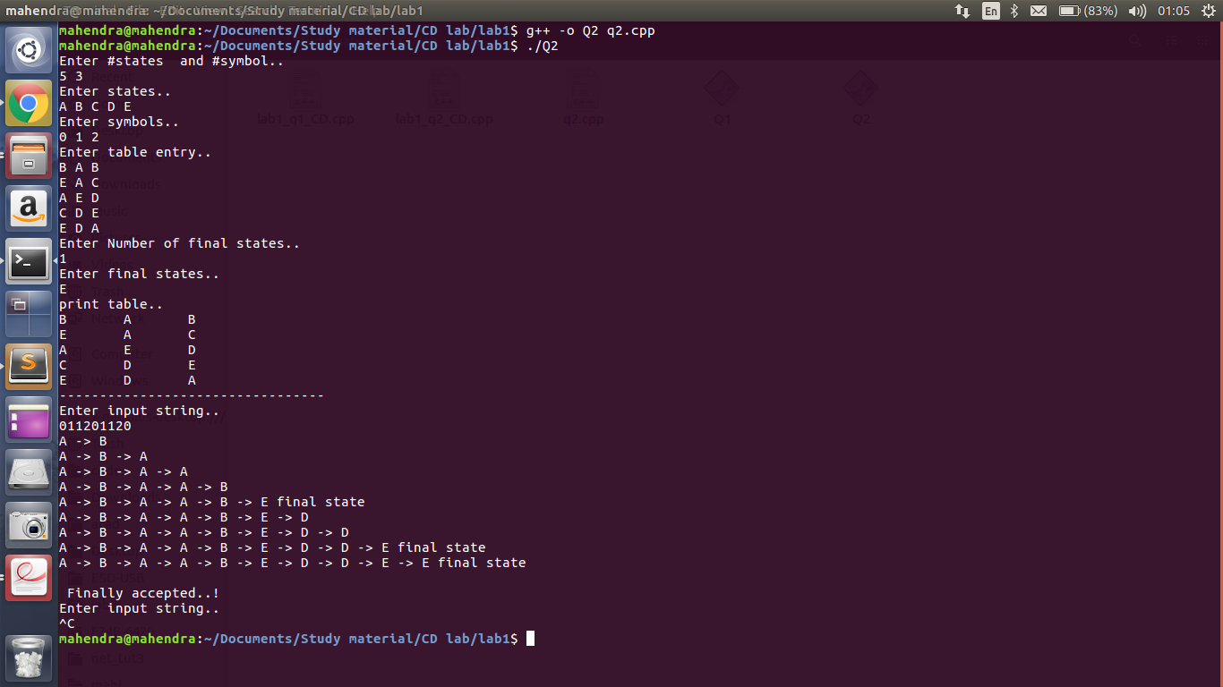
INPUT: 011201120 ouput = accepted
it is showing path followed by DFA to process input.

Q3. Write a program to implement a any given DFA with matrix (i.e. on some input at any .

CODE:

#include <iostream>
#include <bits/stdc++.h>
#include <sstream>
#include <string>
using namespace std;

bool isFinal(char c, char* fin,int N){
bool found=false;
for(int i=0;i<N;i++){
if(fin[i]==c){
found= true;
break;
}
}
return found;
}

int main(){

int m=0,n=0;
// m states and n input symbols
cout<<"Enter #states and #symbol..\n";
cin>>m>>n;
char states[m];
cout<<"Enter states..\n";
for (int i=0;i<m;i++)
cin>>states[i];

char sym[n];
cout<<"Enter symbols..\n";
for (int i=0;i<n;i++)
cin>>sym[i];

cout<<"Enter table entry..\n";
char st[m][n];
for(int i=0;i<m;i++)
for(int j=0;j<n;j++)
cin>>st[i][j];

//char cst=states[0];
cout<<"Enter Number of final states..\n";
int f;
cin>>f;
char fst[f];
cout<<"Enter final states..\n";
for(int i=0;i<f;i++)
cin>>fst[i];

cout<<"print table..\n";
for(int i=0;i<m;i++)
{for(int j=0;j<n;j++)
cout<<st[i][j]<<" ";
cout<<endl;
}

cout<<"---------------------------------"<<endl;
while(true){
char cst=states[0];

string str="A";

//string str=states[0].toString();
// symbol input
cout<<"Enter input string..\n";
// here $ means blank

string S;
cin>>S;
int l=S.length();
char instring[l];
strcpy(instring, S.c_str());
int k=0;
bool accept= false;

while(k<l){

//int nst;
//cin>>nst;

cst=st[(int)((int)cst-(int)(states[0]))][(int)(instring[k])-(int)(sym[0])];
if(cst!='$'){

str=str+" -> " +cst;
cout<<str;
if(isFinal(cst,fst,f)==true){accept=true;cout<<" final state";}
else
accept=false;
cout<<endl;
k++;
}
else {
accept=false;
cout<<"reached dead state..\n";
k=l;
//break;

}

}
if(accept==true)
cout<<"\n Finally accepted..! \n";
else
cout<<"\n Finally rejected..! \n";
}
return 0;

}

OUTPUT:
 | 0 | 1
->A | B | $
B | C | B
*C | $ | C

INPUT : 011011 Accepted
01100 Rejected

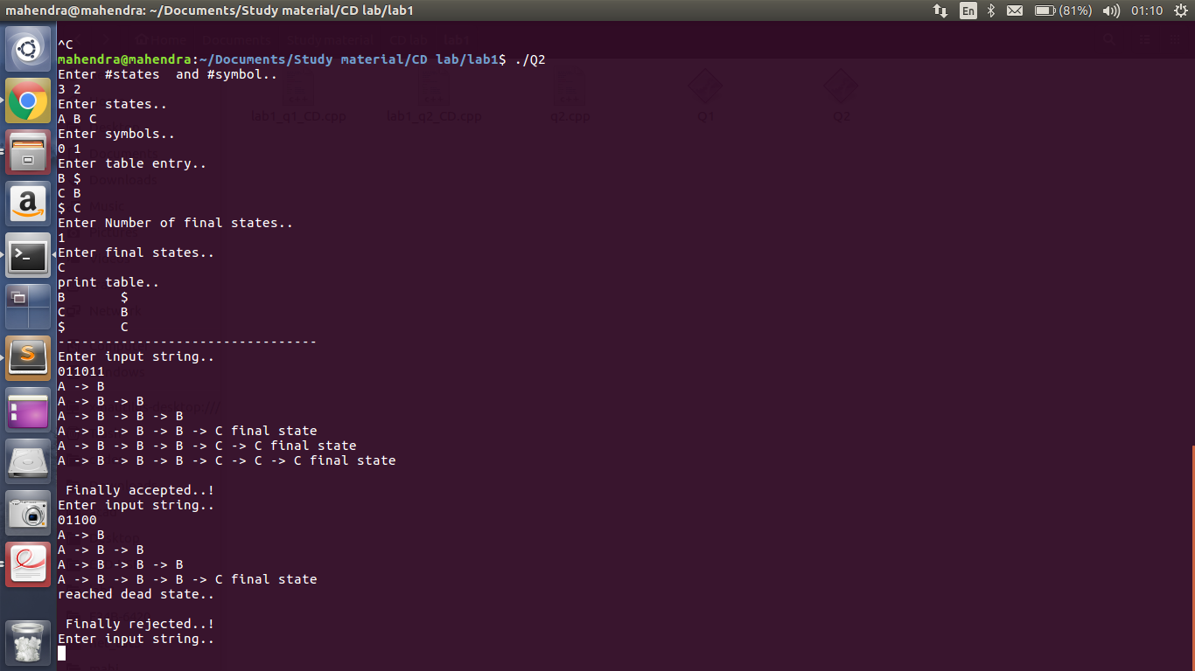

LAB TUTORIAL : 2

Q1. Write a program to convert a NFA to DFA.

INPUT Table | a | b
0 | {1,2}
1 | {1,2}
2 |  | {1,3}
3 | {1,2}

Output table | a | b
{} | {} | {}
0 | {1,2} | {}
{1,2} | {1,2} | {1,3}
{1,3} | {1,2} | {}

Code :

#include<bits/stdc++.h>
using namespace std;
int vis[100],adj[10002][102],v[100];
string s1[10003];
vector<int>a[100][100];
int n,m;
void dfs(int mask,int i)
{
if(adj[mask][i]!=-1)return ;
for(int j=0;j<n;j++)vis[j]=0;
for(int j=0;j<n;j++)
{
if(mask&(1<<j))
{
for(int k=0;k<a[j][i].size();k++)vis[a[j][i][k]]=1;
}
}
int nxt=0;
for(int j=0;j<n;j++)
{
if(vis[j]==1)nxt+=(1<<j);
}
adj[mask][i]=nxt;
for(int j=0;j<m;j++)dfs(nxt,j);

}
int main()
{
cout<<"Enter the number of state"<<endl;
cin>>n;
cout<<"Enter the number of symbol"<<endl;
cin>>m;
cout<<"Enter Transitions"<<endl;
for(int i=0;i<(1<<n);i++)
{
for(int j=0;j<m;j++)adj[i][j]=-1;
}
for(int i=0;i<n;i++)
{
for(int j=0;j<m;j++)
{
int x;
cin>>x;
while(x!=-1)
{
a[i][j].push_back(x);
cin>>x;
}
}
}
cout<<"Enter no of final states"<<endl;
int noe;
cin>>noe;
for(int i=1;i<=noe;i++)
{
int x;
cin>>x;
v[x]=1;
}
for(int i=0;i<m;i++)dfs(1,i);
vector<string>v1;
int cnt=0;
for(int i=0;i<(1<<n);i++)
{
if(adj[i][0]!=-1)
{
cnt++;
bool bl=false;
string str="{";
for(int j=0;j<n;j++)
{
if(i&(1<<j)){str+=(char)('0'+j);str+=',';if(v[j])bl=true;}
}
str+="}";
s1[i]=str;
if(bl)v1.push_back(s1[i]);
}
}
int no_end=v1.size();
cout<<"NO of state "<<cnt<<endl;
cout<<"Start state {0}"<<endl;
cout<<"NO of final states "<<no_end<<endl;
for(int i=0;i<no_end;i++)cout<<v1[i]<<" "<<endl;
for(int i=0;i<(1<<n);i++)
{
if(adj[i][0]!=-1)
{
cout<<s1[i]<<" -> ";
for(int j=0;j<m;j++)cout<<s1[adj[i][j]]<<" ";
cout<<endl;
}
}

}

OUTPUT:

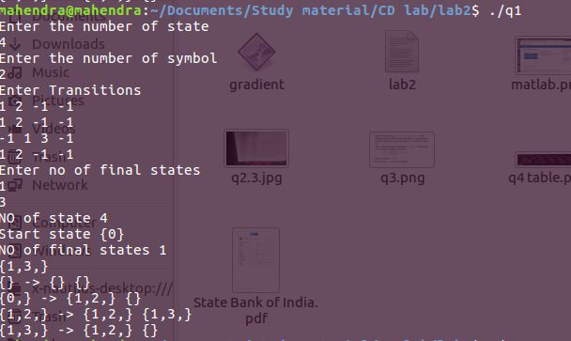

Q2 . Write a program to convert ANY NFA to DFA.
Code : Sam as Q1.

Input table | a | b
0 | {1,2,3} | {2,3}
1 | {1,2} | {2,3}
2 |  | {2,3,4}
3 | {1,4} | {2,3,4}
4

Output table | a | b
0 | {1,2,3} | {2,3}
1,2 | {1,2} | {2,3,4}
2,3 | {1,4} | {2,3,4}
1,2,3 | {1,2,4} | {2,3,4}
1,4 | {1,2} | {2,3}
1,2,4 | {1,2} | {2,3,4}
2,3,4 | {1,4} | {2,3,4}

Input : -1 means end of input
Ouput : {} is dead state

Code explain:

Here I'm using bit masking. Every state is coded with 20 bit number

like :
0 : 00000000000000000001 =2^0=1
1 : 00000000000000000010 =2^1=2
2 : 00000000000000000100 =2^2=4
3 : 00000000000000001000 =2^3=8

Now I'm using recursion (DFS) from start state and finding other states on basis of NFA
like
0 --> {1 ,2} on a
then 00000000000000000001 --> 00000000000000000110 on a

OUTPUT:

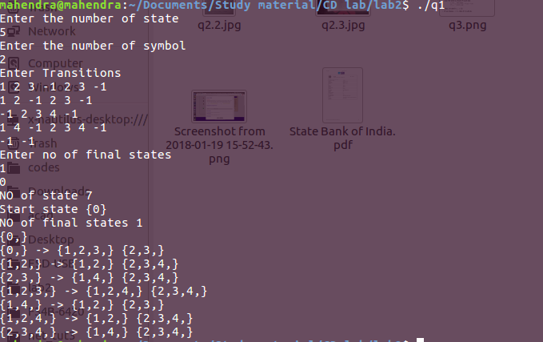

LAB TUTORIAL : 3
Q1. Write a lex program to print line Number before sample program .
Code:

Q2. Write a lex program to print line Number before sample program .
Code :
%option noyywrap

%%
[A-Za-z][A-Za-z0-9]*[^A-Za-z0-9 \t\n] {printf("%s : accepted \n",yytext);}
.* {printf("%s : not accepted \n",yytext);}
%%

main()
{
extern FILE *yyin;
yyin=fopen("xyz.txt","r");
yylex();
}

Input: xyz.txt
ab*
abbbb
*
OUTPUT:
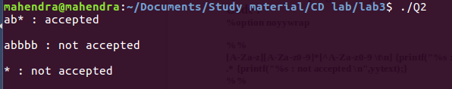

Q3. Write a lex program to print no. Of line, no. Of words, no. Of character in a sample program .

Code :
%{
#include<stdio.h>
int lines=0, words=0,n_char=0;
%}
%%

\n { lines++; words++;}
[\t ' '] {words++;}
[A-Z | a-z | 0-9] {n_char++;}
. n_char++;

%%

main(void)
{
yyin= fopen("abc.txt","r");
yylex();

printf(" This File contains ...");
printf("\n\t%d lines", lines);
printf("\n\t%d words",words);
printf("\n\t%d characters", n_char);

}

int yywrap()
{
return(1);
}
Input: abc.txt
extern printi(val)

sum(a, b) {
return a + b
}

mult(a, b) {
return a * b
}

printi(mult(4, 5) - sum(4, 5))

OUTPUT:
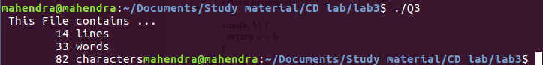

-----------------------

LAB TUTORIAL : 4

Q1. consider the given grammer:

S -> aSbS | bSaS | epsilon

Show that above grammer is ambiguous for string abab.

Ans:

Q2. Write a recursive descent parser for grammer for boolean expression.

E -> E or T | T
T -> T and F | F
F -> not F | (E) | true | false

Code :

#include <bits/stdc++.h>
using namespace std;

int i;
vector<string> inp;

vector<string> split( string s, char delimiter)
{
vector<string> tokens;
int k=0;
int N=s.length();
string tok="";
while(k<N){
if(s[k]==delimiter && tok!="")
{tokens.push_back(tok);
tok="";}
else
tok=tok+s[k];
k++;
}

if(tok!="")
tokens.push_back(tok);

for( int l=0;l<tokens.size();l++){
cout<<tokens[l]<<endl;
}
return tokens;
}

bool term(string s ){
return (inp[i++]==s);
}

bool E();
/*
bool F();
bool T1();
bool T();
bool E1();
*/
bool F(){
int save=i;
return ((i=save,term("not")&&F())
||(i=save,term("(")&& E()&& term(")"))
||(i=save,term("true"))
||(i=save,term("false"))

);
}

bool T1(){
int save=i;
return ((i=save,term("and")&&F()&&T1())
||(i=save,term("and")&& F())

);
}

bool T(){
int save=i;
return ((i=save,F()&&T1())
||(i=save, F())

);

}

bool E1(){
int save=i;
return ((i=save,term("or")&&T()&&E1())
||(i=save, term("or")&&T())

);
}

bool E(){
int save=i;
return ((i=save,T()&&E1())
||(i=save, T())

);
}

int main(){

while(1){
string exp;
cout<<"Enter input"<<endl;
getline(cin,exp);

inp=split(exp,' ');
i=0;

if(E() &&(i==inp.size())){
cout<<"accepted"<<endl;
}
else{
cout<<"rejected"<<endl;
}

}
return 0;

}

OUTPUT :
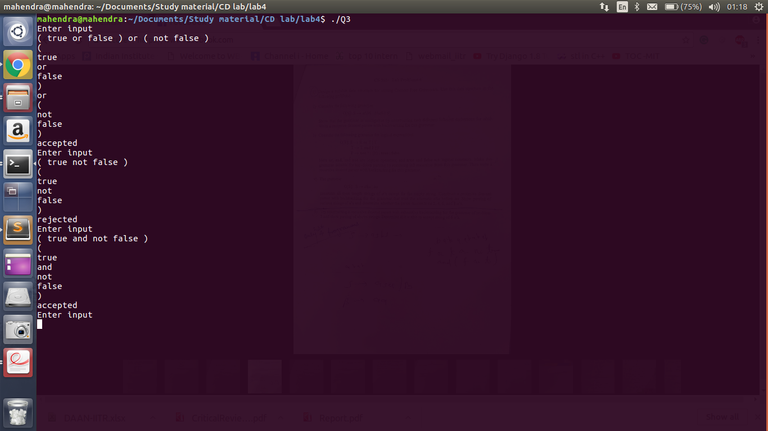
Q 4. construct a recursive descent parser for grammer:
S->aSa | aa
which accept string of even length.

Code:

LAB TUTORIAL : 5

Q1. Write a program to generate FIRST and FOLLOW set of given Grammer.

Code :

#define TRUE 1
#define FALSE 0
#include<iostream>
#include<map>
#include<vector>
#include<string>
#include<fstream>
#include<algorithm>
#include<set>
#include<sstream>
#include<stack>
#include<string>
using namespace std;

map<string, vector<string> >rules;
vector<string> nonTerminals;
set<string> terminals;
map<string, set<string> >firstSet;
map<string, set<string> >followSet;
int letter = 16;
string getString(char x)
{

string s(1, x);

return s;
}
void findFirstSets();
bool produceEpsilon(string);
bool isNonTerminal(string);
void findFollowSets();
void printGrammar();

vector<string> split(string, char, vector<string>&);

int main()
{
ifstream infile;
string rule;

string left, right;

vector<string>::iterator it;

infile.open("Input.txt", ifstream::in);

while(getline(infile, rule))
{
//cout << rule << endl;
int i;
i = 0;
while(rule[i] != ':')
{
left = left + rule[i];
i++;
}
i++;
while(i != rule.length())
{
right = right + rule[i];
i++;
}
//cout << left << endl;
//cout << right << endl;

rules[left].push_back(right);

it = find(nonTerminals.begin(), nonTerminals.end(), left);
if(it == nonTerminals.end())
nonTerminals.push_back(left);

left="";
right="";

}
infile.close();

cout << "Original Grammar-->" << endl;
printGrammar();
//cout << nonTerminals.size() << endl;
//cout << rules.size() << endl;
cout << "---------------------------------" << endl ;

findFirstSets();
findFollowSets();

cout << "--------------------------------" << endl ;

string parsingTable[nonTerminals.size()][terminals.size() + 1];

int i, j;
set<string>::iterator iter;
vector<string> terminals_temp;
cout<<"non terminals are.."<<endl;
for(i = 0; i < nonTerminals.size(); i++)
cout << i << "-->" << nonTerminals[i] << endl;

cout<<"terminals are.."<<endl;
for(j = 0, iter = terminals.begin(); iter != terminals.end(); j++, iter++)
{
terminals_temp.push_back(*iter);
cout << j << "-->" << *iter << endl ;
}

terminals_temp.push_back("$");

cout << "--------------------------------" << endl ;
cout << "Parsing Table" << endl << endl;

for(i = 0; i < nonTerminals.size(); i++)
{
for(j = 0; j < terminals_temp.size(); j++)
parsingTable[i][j] = "";
}

for(i = 0; i < nonTerminals.size(); i++)
{
for(it = rules[nonTerminals[i]].begin(); it != rules[nonTerminals[i]].end(); it++)
{
//cout << "Rule-->" << nonTerminals[i] << ":" << *it << endl;
vector<string> temp;
vector<string>::iterator x;
split(*it, ' ', temp);
set<string>::iterator it_s;
for(x = temp.begin(); x != temp.end(); x++)
{
//cout << *x << endl;
for(it_s = firstSet[*x].begin(); it_s != firstSet[*x].end(); it_s++)
{
if(*it_s != "#") //checking for non epsilon production
{
for(j = 0; j < terminals_temp.size(); j++)
{
if(terminals_temp[j] == *it_s)
//parsingTable[i][j].push_back(*it);
{
if(parsingTable[i][j] == "")
{
//cout << "Inserted " << *it << " " << nonTerminals[i] << " " << terminals_temp[j] << endl;
parsingTable[i][j] = *it;
}
else
{
//cout << "Returned" << endl;
cout << "Grammar not LL(1)" << endl;
exit(1);
}
}
}
}
}

if(firstSet[*x].find("#") == firstSet[*x].end())
{
//cout << "Break! " << *x << endl;
break;
}
}

for(x = temp.begin(); x != temp.end(); x++)
{

if(firstSet[*x].find("#") == firstSet[*x].end())
{
//cout << "Broken! " << *x << endl;
break;
}
}

if(x == temp.end())
{
for(it_s = followSet[nonTerminals[i]].begin(); it_s != followSet[nonTerminals[i]].end(); it_s++)
{
for(j = 0; j < terminals_temp.size(); j++)
{
if(terminals_temp[j] == *it_s)
//parsingTable[i][j].push_back(*it);
{
if(parsingTable[i][j] == "")
{
//cout << "Inserted1 " << *it << " " << nonTerminals[i] << " " << terminals_temp[j] << endl;
parsingTable[i][j] = *it;
}
else
{
//cout << "From Here" << endl;
cout << "Grammar not LL(1)" << endl;
exit(1);
}
}
}
}
}
}
}

//cout << endl;
for(i = 0; i < nonTerminals.size(); i++)
{
for(j = 0; j < terminals_temp.size(); j++)
{
if(parsingTable[i][j] == "")
cout << "ERR\t";
else
cout << parsingTable[i][j] << "\t" ;
}
cout << endl;
}
cout << "--------------------------------" << endl ;
//string s;
//s = parsingTable[0][5][0];
//cout << s ;
while(1){
string input;
cout << "Enter an input string:" << endl;

getline(cin, input);
//cout << input << endl;

vector<string>inp_split;
//split(input, ' ', inp_split);
for(int i=0;i<input.length();i++)
inp_split.push_back(getString(input[i]));
inp_split.push_back("$");
/*

if(input=="bda" || input=="da" || input=="ba" || input =="a")
{
cout<<"Accepted\n";
return 0;
}
*/
vector<string>::iterator it_inp;
stack<string> t;
int k;
t.push("$");
t.push(nonTerminals[0]);

it_inp = inp_split.begin();

while(1)
{
cout << "TOP--> " << t.top() << " INPUT--> " << *it_inp << endl;
if(*it_inp == "$" && t.top() == "$")
{
cout << "Accepted" << endl;
break;
}
if(t.top() != "$" && terminals.find(t.top()) != terminals.end())
{
t.pop();
it_inp++;
}
else
{
for(i = 0; i < nonTerminals.size(); i++)
{
if(nonTerminals[i] == t.top())
break;
}
for(j = 0; j < terminals_temp.size(); j++)
{
if(terminals_temp[j] == *it_inp)
break;
}
//cout << "I--> " << i << " J--> " << j << endl;
if(parsingTable[i][j] == "")
{
cout << "Rejected" << endl;
break;
}
else
{
//cout << "Inside" << endl;
t.pop();
string str;
vector<string> str_v;
str = parsingTable[i][j];
//cout << "Entry--> " << str << endl;
if(str != "#")
{
split(str, ' ', str_v);
for(k = str_v.size() - 1; k >= 0; k--)
t.push(str_v[k]);
}
}
}
}

//input while loop end
}
return 0;
}

void printGrammar()
{
for(int i = 0; i < nonTerminals.size(); i++)
{
for(int j = 0; j < rules[nonTerminals[i]].size(); j++)
{
cout << nonTerminals[i] << "\t" << rules[nonTerminals[i]][j] << endl ;
}
}
}

void findFirstSets()
{
int i, j, k;
bool result;
vector<string>::iterator pos;
vector<string> t;
set<string>::iterator it;
map<string, set<string> >::iterator xy;

for(i = 0; i < nonTerminals.size(); i++)
{
for(k = 0; k < rules[nonTerminals[i]].size(); k++)
{
split(rules[nonTerminals[i]][k], ' ', t);

for(j = 0; j < t.size(); j++)
{
//cout << "Split " << t[j] << endl;
pos = find(nonTerminals.begin(), nonTerminals.end(), t[j]);
if(pos == nonTerminals.end())
{
firstSet[t[j]].insert(t[j]);
terminals.insert(t[j]);
}
}
}
result = produceEpsilon(nonTerminals[i]);
if(result)
firstSet[nonTerminals[i]].insert("#");
//cout << nonTerminals[i] << "S-->" << result << endl;

t.clear();
}

t.clear();

vector<string>::iterator iter, iter_v;

result = TRUE;

while(result)
{
result = FALSE;

//cout << "New Iteration" << endl;
for(iter = nonTerminals.begin(); iter != nonTerminals.end(); iter++)
{
for(iter_v = rules[*iter].begin(); iter_v != rules[*iter].end(); iter_v++)
{
vector<string> temp;
vector<string>::iterator it_temp;
split(*iter_v, ' ', temp);
for(it_temp = temp.begin(); it_temp != temp.end(); it_temp++)
{
if(isNonTerminal(*it_temp))
{
if(!produceEpsilon(*it_temp))
{ // if not produces epsilon
set<string>::iterator it_s;
if(firstSet.find(*it_temp) != firstSet.end())
{
for(it_s = firstSet[*it_temp].begin(); it_s != firstSet[*it_temp].end(); it_s++)
{
if(firstSet[*iter].find(*it_s) == firstSet[*iter].end())
result = TRUE;
firstSet[*iter].insert(*it_s);
}
//cout << "END" << endl;
}
break;
}
else
{ //produces epsilon then insert all first of that non terminal
set<string>::iterator it_s;
if(firstSet.find(*it_temp) != firstSet.end())
{
for(it_s = firstSet[*it_temp].begin(); it_s != firstSet[*it_temp].end(); it_s++)
{
if(firstSet[*iter].find(*it_s) == firstSet[*iter].end())
result = TRUE;
firstSet[*iter].insert(*it_s);
}

}

}

}
else
{ //put terminals direclty
if(*it_temp != "")
{
if(firstSet[*iter].find(*it_temp) == firstSet[*iter].end())
{
//cout << "Insert " << *it_temp << " in first " << *iter << endl;
result = TRUE;
}
firstSet[*iter].insert(*it_temp);
break;
}
}
}
}
}
}

//cout << "Terminals" << endl;
//for(it = terminals.begin(); it != terminals.end(); it++)
// cout << *it << endl;

cout << "---------------------------------" << endl;
cout << "First Sets-->" << endl;

for(xy = firstSet.begin(); xy != firstSet.end(); xy++)
{
cout << xy->first << "--> ";
for(it = xy->second.begin(); it != xy->second.end(); it++)
{
cout << *it << " ";
}
cout << endl;
}
}

vector<string> split(string s, char delim, vector<string> &elems)
{
stringstream ss(s);
string item;
while(getline(ss, item, delim))
{
elems.push_back(item);
}
return elems;
}

bool produceEpsilon(string str)
{
//cout << "Called-->" << str << endl;
int i, j;
vector<string> x;
vector<string>::iterator it;
bool yes;

for(i = 0; i < rules[str].size(); i++)
{
//cout << "Rules " << rules[str][i] << endl;
if(rules[str][i] == "#"){//cout << "dir #\n";
return TRUE; }
}

//cout << "Size" << rules[str].size();

for(i = 0; i < rules[str].size(); i++)
{
split(rules[str][i], ' ', x);

//cout << "Length " << rules[str][i] << " " << rules[str][i].length() << endl;
int has;

for(j = 0; j < x.size(); j++)
{
has = 0;
//cout << "x[j] -->" << x[j] << endl;

yes = isNonTerminal(x[j]);
if(yes)
{ // checking recursively
if(!produceEpsilon(x[j]))//{ cout << "not produce\n";
return FALSE;//}
else
has = 1;
}
else
break;
}
x.clear();
if(has)
return TRUE;
}
return FALSE;
}

bool isNonTerminal(string s)
{
vector<string>::iterator it;
for(it = nonTerminals.begin(); it != nonTerminals.end(); it++)
{
if(*it == s)
return TRUE;
}
return FALSE;
}

void findFollowSets(){
set<string>::iterator it;
int i,j;
vector<string>::iterator x;
vector<string>::iterator itnt;

followSet[nonTerminals[0]].insert("$"); // starting has $ as follow

for(itnt = nonTerminals.begin(); itnt != nonTerminals.end(); itnt++)
{
for(x = rules[*itnt].begin(); x != rules[*itnt].end(); x++)
{
vector<string> temp;
int k;
split(*x, ' ', temp);
for(k = 0; k < temp.size() - 1; k++)
{
set<string>::iterator it_set;
for(it_set = firstSet[temp[k + 1]].begin(); it_set != firstSet[temp[k+1]].end(); it_set++)
{
if(*it_set != "#")
followSet[temp[k]].insert(*it_set);
}
}
}
}

map<string ,set<string> >::iterator xy;
set<string>::iterator z;

bool result = TRUE;

while(result)
{
result = FALSE;
for(itnt = nonTerminals.begin(); itnt != nonTerminals.end(); itnt++)
{
for(x = rules[*itnt].begin(); x != rules[*itnt].end(); x++)
{
vector<string> temp;
split(*x, ' ', temp);
for(i = 0; i < temp.size() - 1; i++)
{
for(j = i + 1; j < temp.size(); j++)
{
if(firstSet[temp[j]].find("#") == firstSet[temp[j]].end())
break;
}
if(j == temp.size())
{ //in S -> AX follow (X) will contain follow(S)
set<string>::iterator it_s;
if(followSet.find(*itnt) != followSet.end())
{
for(it_s = followSet[*itnt].begin(); it_s != followSet[*itnt].end(); it_s++)
{
if(followSet[temp[i]].find(*it_s) == followSet[temp[i]].end())
result = TRUE;
followSet[temp[i]].insert(*it_s);
}
}
}
}

set<string>::iterator s_it;
if(followSet.find(*itnt) != followSet.end())
{
for(s_it = followSet[*itnt].begin(); s_it != followSet[*itnt].end(); s_it++)
{
if(followSet[temp[i]].find(*s_it) == followSet[temp[i]].end())
result = TRUE;
followSet[temp[i]].insert(*s_it);
}
}
}
}
}

cout << "-------------------------------------" << endl;
cout << "Follow Sets" << endl;

for(xy = followSet.begin(); xy != followSet.end(); xy++)
{
if(xy->first != "#")
{
cout << xy->first << "--> " ;
for(z = xy->second.begin(); z != xy->second.end(); z++)
cout << *z << " ";
cout << endl;
}

}
}
/*
E:T X
X:+ E
X:#
T:( E )
T:int Y
Y:* T
Y:#
*/
/*
S:A a
A:B D
B:b
B:#
D:d
D:#

*/

Input Grammer : (in input.txt)
E:T X
X:+ E
X:#
T:( E )
T:int Y
Y:* T
Y:#

here # : epsilon

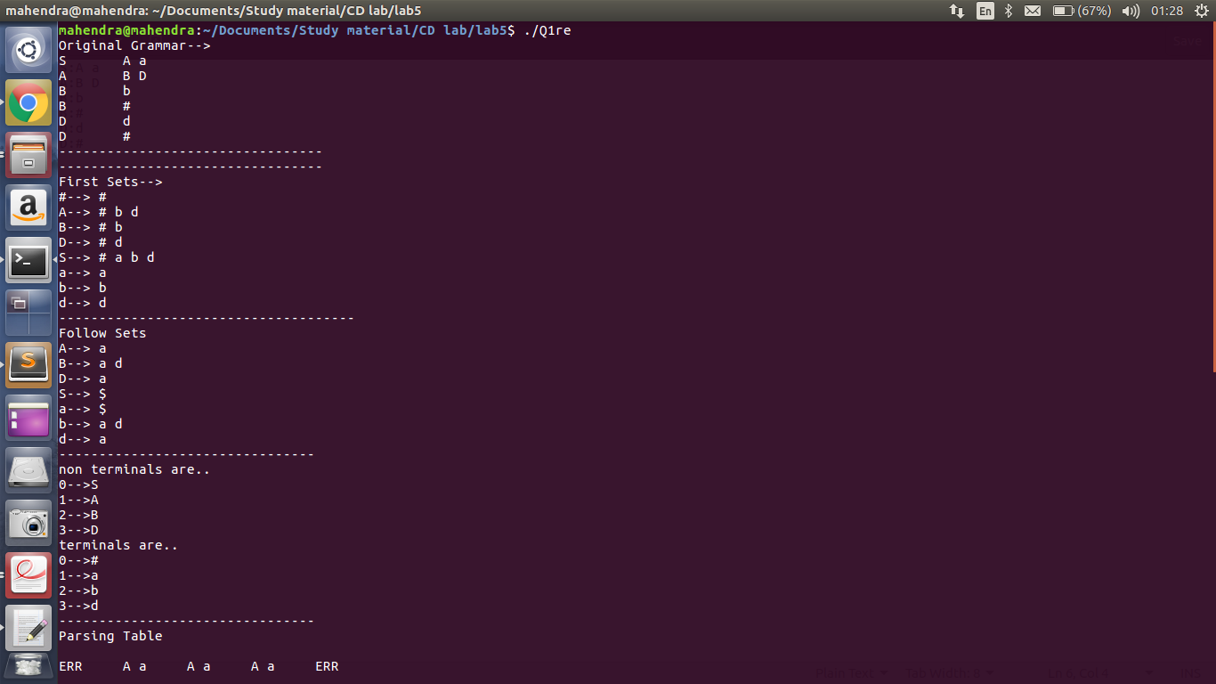
Output:

Q2. write a program that create predictive parsing table.
Code : This feature is included in code of Q1

Output:
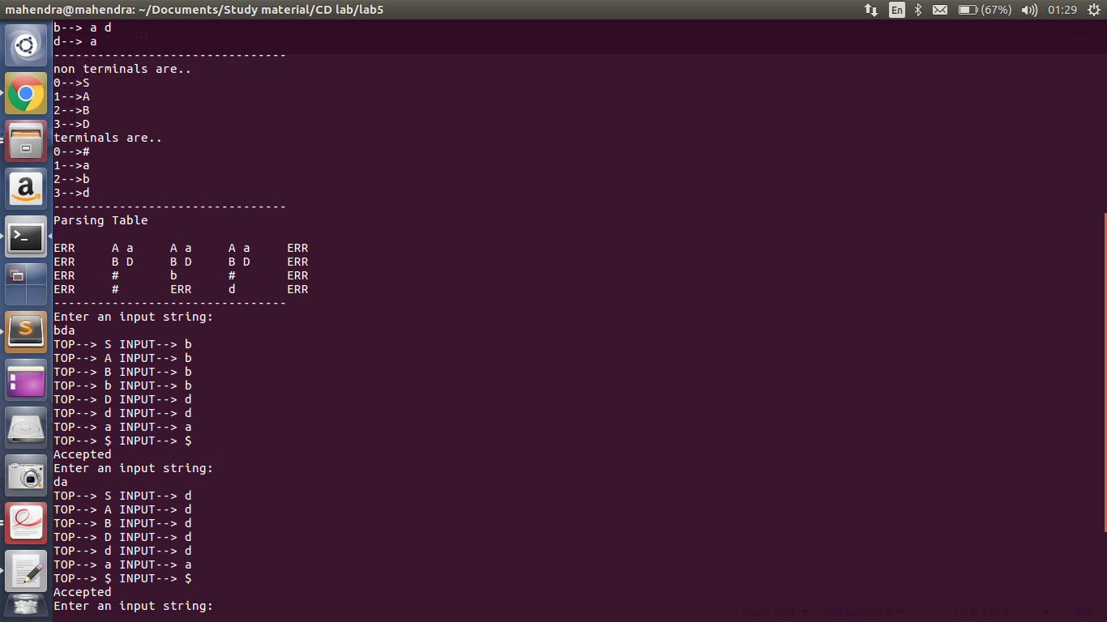
Here ERR – in table is blank entry in table.

Q3. write a program LL(1) parser and check whether a given string is accepted or not.
Code : This feature is included in code of Q1

Output:

Q4. Implement operator precedence parser.

Code:
#include<bits/stdc++.h>

#include<string.h>
using namespace std;
char *input;
int i=0;
char lasthandle[9],stack1[50],handles[][8]={")E(","E*E","E+E","E-E","E/E","E-","i","E^E"};
//(E) becomes )E( when pushed to stack1

int top=0,l;
char prec[9][9]={

/*input*/

/*stack1 + - * / ^ i ( ) $ */

/* + */ '>', '>','<','<','<','<','<','>','>',

/* - */ '>', '>','<','<','<','<','<','>','>',

/* * */ '>', '>','>','>','<','<','<','>','>',

/* / */ '>', '>','>','>','<','<','<','>','>',

/* ^ */ '>', '>','>','>','<','<','<','>','>',

/* i */ '>', '>','>','>','>','e','e','>','>',

/* ( */ '<', '<','<','<','<','<','<','>','e',

/* ) */ '>', '>','>','>','>','e','e','>','>',

/* $ */ '<', '<','<','<','<','<','<','<','>',

};

int getindex(char c)
{
switch(c)
{
case '+':return 0;
case '-':return 1;
case '*':return 2;
case '/':return 3;
case '^':return 4;
case 'i':return 5;
case '(':return 6;
case ')':return 7;
case '$':return 8;
}
}

int shift()
{
stack1[++top]=*(input+i++);
stack1[top+1]='\0';
}

int reduce()
{
int i,len,found,t;
for(i=0;i<8;i++)//selecting handles
{
len=strlen(handles[i]);
if(stack1[top]==handles[i][0]&&top+1>=len)
{
found=1;
for(t=0;t<len;t++)
{
if(stack1[top-t]!=handles[i][t])
{
found=0;
break;
}
}
if(found==1)
{
stack1[top-t+1]='E';
top=top-t+1;
strcpy(lasthandle,handles[i]);
stack1[top+1]='\0';
return 1;//successful reduction
}
}
}
return 0;
}

void dispstack1()
{
int j;
for(j=0;j<=top;j++)
printf("%c",stack1[j]);
}

void dispinput()
{
int j;
for(j=i;j<l;j++)
printf("%c",*(input+j));
}

int main()
{
int j;

input=(char*)malloc(50*sizeof(char));
printf("\nEnter the string\n");
scanf("%s",input);
input=strcat(input,"$");
l=strlen(input);
strcpy(stack1,"$");
printf("\nstack1\tINPUT\tACTION");
while(i<=l)
{
shift();
printf("\n");
dispstack1();
printf("\t");
dispinput();
printf("\tShift");
if(prec[getindex(stack1[top])][getindex(input[i])]=='>')
{
while(reduce())
{
printf("\n");
dispstack1();
printf("\t");
dispinput();
printf("\tReduced: E->%s",lasthandle);
}
}
}

if(strcmp(stack1,"$E$")==0)
printf("\nAccepted\n");
else
printf("\nNot Accepted\n");
return 0;
}

Output :
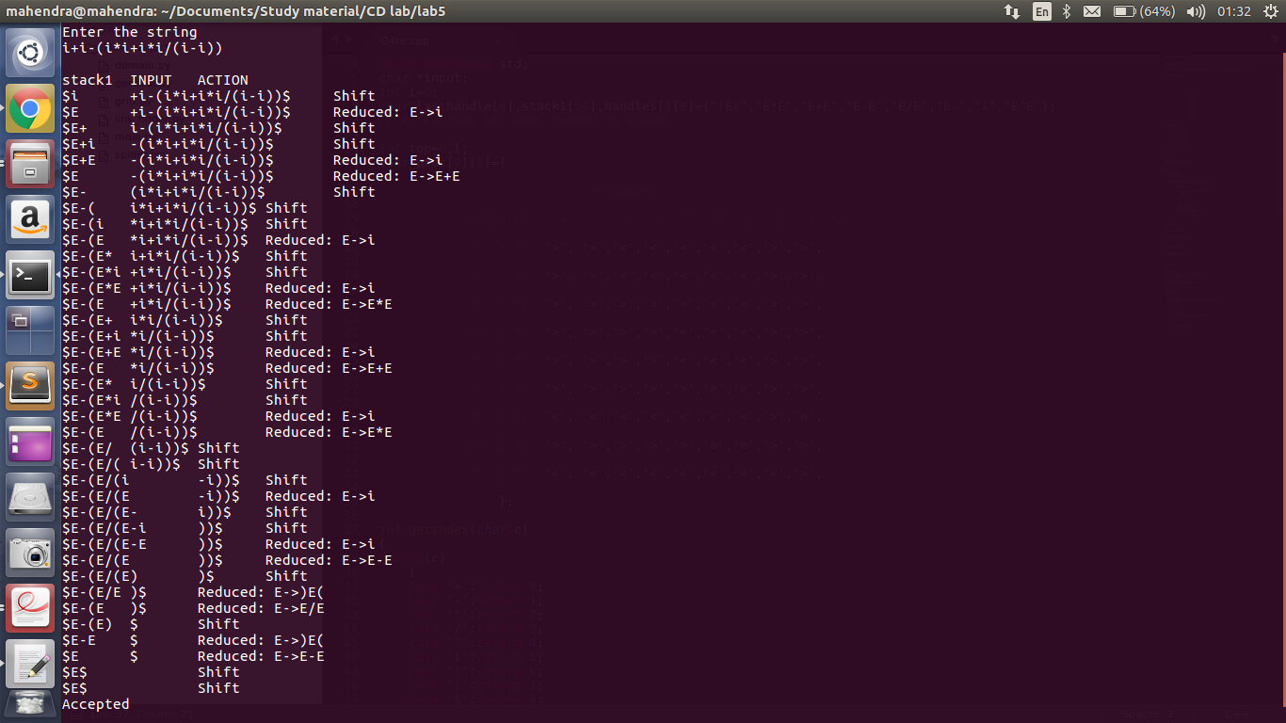

Q5. Write LR(1) parser that parses input string using given LR parsing table.

Code:

action_table = {'S0': {'i': 'S3'},
'S1': {'$': '@'},
'S2': {'+': 'S4', '$':'R2'},
'S3': {'+': 'R3', '$':'R3'},
'S4': {'i':'S3'},
'S5': {'$':'R1'}
}
goto_table = {'S0': {'E':'S1', 'T':'S2'},
'S1': {},
'S2': {},
'S3': {},
'S4': {'E':'S5', 'T':'S2'},
'S5': {}
}

print "Enter your string: "
inp = raw_input()
inp += '$'
stack = [('dummy', 'S0')]

j = 0

while True:
print "input read: ", inp[j]
if inp[j] in action_table[stack[-1][1]]:
act = action_table[stack[-1][1]][inp[j]]
if act == '@':
print "*****************Accepted\n"
break
elif act[0] == 'S':
stack.append((inp[j], act))
print "Shift: ", act
j += 1
elif act[0] == 'R':
if act == 'R0':
stack.pop()
stack.append(('S', goto_table[stack[-1][1]]['S']))
print "Reduction: S -> E"
elif act == 'R1':
stack.pop()
stack.pop()
stack.pop()
stack.append(('E', goto_table[stack[-1][1]]['E']))
print "Reduction: E -> T+E"
elif act == 'R2':
stack.pop()
stack.append(('E', goto_table[stack[-1][1]]['E']))
print "Reduction: E -> T"
else:
stack.pop()
stack.append(('T', goto_table[stack[-1][1]]['T']))
print "Reduction: T -> i"

else:
print "****************Error, Not Accepted\n"
break

Output:
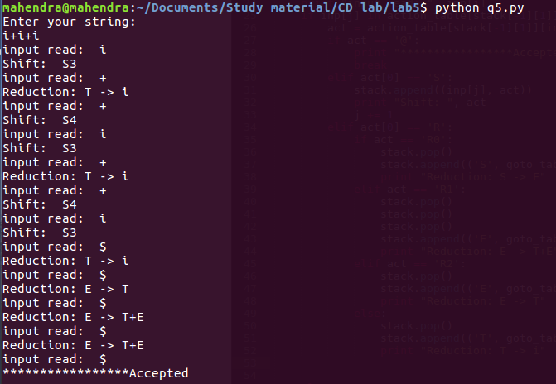
Here i represent int.

LAB TUTORIAL : 6
Q 1 . Write YACC program for desk calculator to evaluate arithmatic expressions.
Code:
Q1.lex
%{

#include <stdio.h>
#include "y.tab.h"
int c;
%}
%%
" " ;
[a-z] {
c = yytext[0];
yylval.a = c - 'a';
return(LETTER);
}
[0-9] {
c = yytext[0];
yylval.a = c - '0';
return(DIGIT);
}
[^a-z0-9\b] {
c = yytext[0];
return(c);
}
%%
Compile : lex Q1.lex

Q1.yacc
%{
#include<stdio.h>

int regs[26];
int base;

%}

%start list

%union { int a; }

%token DIGIT LETTER

%left '|'
%left '&'
%left '+' '-'
%left '*' '/' '%'
%left UMINUS /*supplies precedence for unary minus */

%% /* beginning of rules section */

list: /*empty */
|
list stat '\n'
|
list error '\n'
{
yyerrok;
}
;
stat: expr
{
printf("%d\n",$1);
}
|
LETTER '=' expr
{
regs[$1.a] = $3.a;
}

;

expr: '(' expr ')'
{
$$ = $2;
}
|
expr '*' expr
{

$$.a = $1.a * $3.a;
}
|
expr '/' expr
{
$$.a = $1.a / $3.a;
}
|
expr '%' expr
{
$$.a = $1.a % $3.a;
}
|
expr '+' expr
{
$$.a = $1.a + $3.a;
}
|
expr '-' expr
{
$$.a = $1.a - $3.a;
}
|
expr '&' expr
{
$$.a = $1.a & $3.a;
}
|
expr '|' expr
{
$$.a = $1.a | $3.a;
}
|

'-' expr %prec UMINUS
{
$$.a = -$2.a;
}
|
LETTER
{
$$.a = regs[$1.a];
}

|
number
;

number: DIGIT
{
$$ = $1;
base = ($1.a==0) ? 8 : 10;
} |
number DIGIT
{
$$.a = base * $1.a + $2.a;
}
;

%%
main()
{
return(yyparse());
}

yyerror(s)
char *s;
{
fprintf(stderr, "%s\n",s);
}

yywrap()
{
return(1);
}
Compile : yacc -d Q1.yacc
Then compile both : cc y.tab.c lex.yy.c
Run : ./a.out
Output:
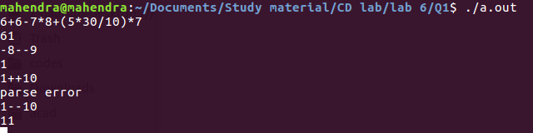

Q 2. Write YACC program for desk calculator to evaluate boolean expressions.
Here 0 : false
1 : true
Code:
Q2.lex
%{

#include <stdio.h>
#include "y.tab.h"
int c;
%}
%%
" " ;
[a-z] {
c = yytext[0];
yylval.a = c - 'a';
return(LETTER);
}
[0-9] {
c = yytext[0];
yylval.a = c - '0';
return(DIGIT);
}
[^a-z0-9\b] {
c = yytext[0];
return(c);
}
%%

Q2.yacc
%{
#include<stdio.h>

int regs[26];
int base;

%}

%start list

%union { int a; }

%token DIGIT LETTER

%left '|'
%left '^'

%left '&'

%left '+' '-'
%left '*' '/' '%'

%right '~'

%left UMINUS /*supplies precedence for unary minus */

%% /* beginning of rules section */

list: /*empty */
|
list stat '\n'
|
list error '\n'
{
yyerrok;
}
;
stat: expr
{
printf("%d\n",$1);
}
|
LETTER '=' expr
{
regs[$1.a] = $3.a;
}

;

expr: '(' expr ')'
{
$$ = $2;
}
|
'~' expr
{

$$.a = ! $2.a;
}
|
expr '&' expr
{

$$.a = $1.a & $3.a;
}
|
expr '|' expr
{
$$.a = $1.a | $3.a;
}
|
expr '^' expr
{
$$.a = $1.a ^ $3.a;
}
|
'-' expr %prec UMINUS
{
$$.a = -$2.a;
}
|
LETTER
{
$$.a = regs[$1.a];
}

|
number
;

number: DIGIT
{
$$ = $1;
base = ($1.a==0) ? 8 : 10;
} |
number DIGIT
{
$$.a = base * $1.a + $2.a;
}
;

%%
main()
{
return(yyparse());
}

yyerror(s)
char *s;
{
fprintf(stderr, "%s\n",s);
}

yywrap()
{
return(1);
}
Output:
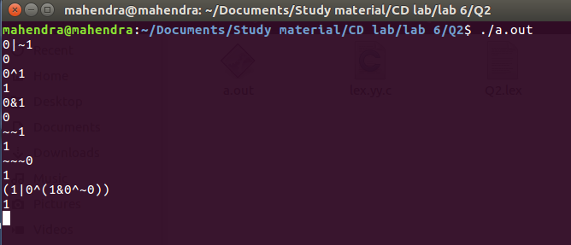
Q 3. Write YACC program to produce parse tree from regular expression.

Code:

Q 4. Write YACC program to produce postfix of given arithmatic expression.
Code:
%{
#include<stdio.h>
%}
%token INTEGER
%left '+' '-'
%left '*' '/'
%%

E: E '+' T {printf("+");}
| E '-' T {printf("-");}
| T
;

T: T '*' F {printf("*");}
| T '/' F {printf("/");}
| F
;

F: '(' E ')'
| INTEGER {printf("%d",yylval);}
;

%%

int main(){
yyparse();
printf("\n");
}

int yyerror (char *msg) {
return printf ("error YACC: %s\n", msg);
}

Output:
